FLIPKART SALES SQL QUERIES
A.KPI’S
- Average Price:
select avg(Price) from flipkart_products;
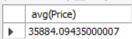

- Average Rating :
select avg(Rating) from flipkart_products;
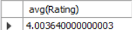

- Average Buyers:
select avg(Buyers) from flipkart_products;
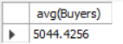

- Average Product Sold:
select avg(Total_Sold) from flipkart_products;
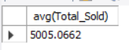
- Average Discount:
select avg(`Discount(%)`) from flipkart_products;
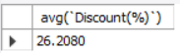

B. OTHER PARAMETERS:
1. Average Rating Per Category:
select avg(Rating),Main_Category from flipkart_products group by Main_Category;
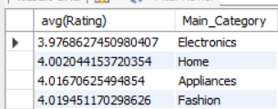
2. Average Price Per Category:
select avg(Price),Main_Category from flipkart_products group by Main_Category;
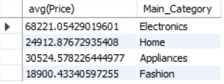
3. Average Product Per Category:
select count(Product_Name),Main_Category from flipkart_products group by Main_Category;
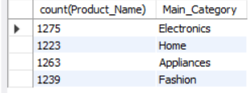

4. Average Discount Per Category:
select avg(`Discount(%)`),Main_Category from flipkart_products group by Main_Category;
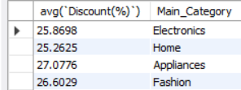
- Average Product Listed Per Seller:
select count(Product_Name),Seller from flipkart_products group by Seller;
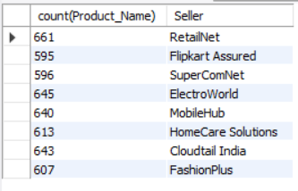

- Average Rating per Seller:
select avg(Rating),Seller from flipkart_products group by Seller;
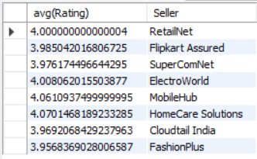
- Average Buyer Per Sub Category:
select avg(Buyers),Sub_Category from flipkart_products group by Sub_Category;
